The Game Outside the Game
Andrew Wolf
Magic players are notorious for their behavior patterns. It is amazing to witness particular behaviors and attitudes, repeated over and over. Who can say that they have never overslept, showing up for a tournament or event mere moments before registration closes, or even a few minutes late, resulting in a round of begging and pleading to be allowed to play? Or how about the time when someone spent the fifteen minutes before the tournament began running around trying to find someone who could provide you with those last few precious cards for your sideboard? Everyone is occasionally guilty of these kinds of things, and they can really affect a player's game.

Physical and mental preparations that are often lacking in a player's game
These are some of the more abstract issues players' face when preparing to play Magic, but they are important. While the topics discussed here do tend to relate more to the tournament-level Magic playing community, the issues are really relevant across the board, to everyone. How a player gets up for the game is just as important as the decisions one makes during the course of a match, the kinds of things one does (or occasionally neglects doing) to ready him or herself for a day or evening of Magic. Not only are building a deck, honing a sideboard, or playing in some practice drafts important, but also critical to success are the physical and mental preparations that are often lacking in a player's game.
A lot of this may seem like common sense, but nevertheless, these kinds of behaviors are repeated over and over again. Magic players by their nature need not be lazy, sloppy, or forgetful, yet these kinds of behavioral traits are displayed all the time. Fear not! There are a few things Magic players can do that will really help them get up for the game.
1. Get a good night of sleep. A tournament is important. Show up for it well rested and feeling refreshed, not run-down and tired. No one who has ever had an important job interview the next morning would stay out late the night before it, only to show up tired and groggy the next morning. It should not be any different for a tournament. Some time in the next few weeks, when there is a tournament, look around in-between rounds. Surely there will be a few players with their heads on the table, trying to catch up on a little rest, so they can remain fresh and alert, but they probably are not playing at the top tables.
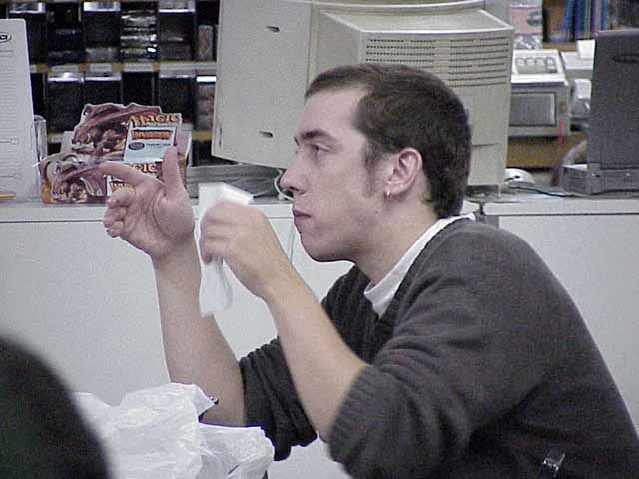
Dave Price takes some time for lunch
2. Eat. Before showing up for the tournament, get a little something to eat. Playing on an empty stomach is never a good idea. A player will find that he or she has a lower energy level, and probably will be distracted by a gnawing hunger, too. Find a little time during the tournament to eat, as well. Take advantage of matches that end quickly to duck out and find some food. It will pay off later.
3. Be prepared. This involves a lot of things, starting with knowing where and when the tournament is being held. There is nothing like getting lost on the way to or showing up late for a tournament to put a damper on the day. Pre-registration is a blessing; it removes one unnecessary hassle for a player when he or she finally does show up for the event. It will usually end up saving you some money, too.
If the event is a Constructed tournament, a player should make sure beforehand to show up with whatever deck he or she is going to play, or at least have it narrowed down to just a few choices. And a player should always have the deck, or decks if one wants more than one to choose from, already built, complete with sideboard. If possible, have a deck list filled out ahead of time. Make sure to double-check anything that is registered in writing. Get a buddy to check it, too, if possible. There are countless numbers of times where someone is doing well in a tournament, only to receive a game or match loss for a misregistered deck. It is just sloppy, and there really is no excuse for it. Harsh penalties are often given out for such sloppiness, and that really is the way it should be. It is not acceptable in other sporting events, and it should not be in Magic, too. The community-at-large will not take Magic seriously as an intellectual sport if such sloppiness is allowed to continue.
Also, a player should have with him or her any other materials that might be needed during the event. Bring paper and pencil, to keep track of life totals. Have a way to determine who will play/draw first. Have tokens or counters if they might be necessary during the event. Bring extra sleeves, in case one breaks. Anything else that might be needed, have it all organized the night before, to avoid running around minutes before the event starts, desperately trying to find that one critical item left at home. Do not rely on someone else to remember these things. Be responsible.
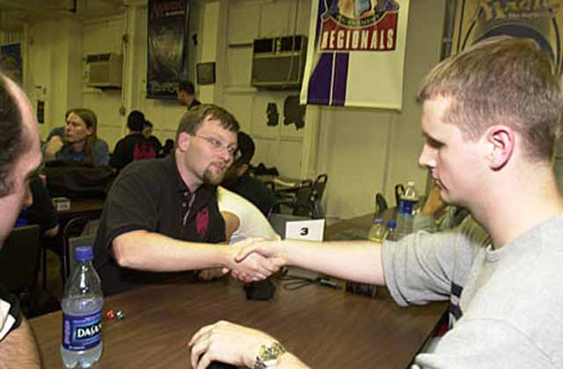
4. Try and be a good sport. Everyone knows this can sometimes be difficult, given the level of emotion that a tournament can generate. Sometimes it can be very difficult to remain friendly and cordial, and yes, some players are rude and unsportsmanlike on purpose as part of their game, but in the end, everyone will find his or her gaming experiences much more positive if everyone carries a positive attitude. Try not to get frustrated or upset by a bad play or bad luck; it will only throw off focus and concentration, and make it that much more likely that additional errors will be committed. Have a good time, that is one of the reasons why everyone started playing Magic in the first place.
Well, one could go on and on about the kinds of things should be done to get up for the game, and a lot of it is probably pretty obvious to everyone already, so enough already. If everyone starts giving it a little more serious consideration, it can only help further promote and improve this game that we have embraced.

